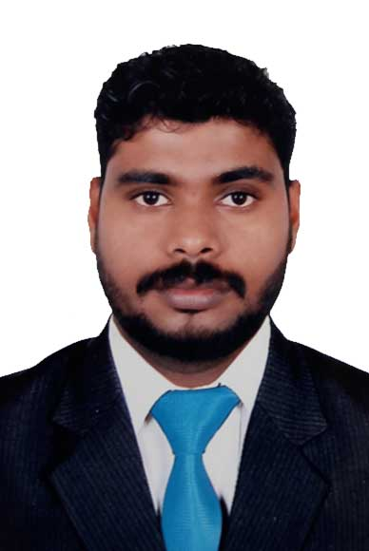

C U R R I C U L A M – V I T A E

VINEETH.E.C
Auto Mobile Engineer
P o s t B o x : 955
R a s A l K h a i m a h – U.A.E,
E- Mail vineethec33@gmail.com
Mobile: + 9 7 1 50 777 99 48

Professional Objectives:
To adhere with an organization, which can give me an excellent opportunity to display my auto mobile skills and dedicate myself to the goals and objectives for which the firm stands.

Professional Experience:
Total 4 years experience in India with leading vehicle repairing and maintenance
Companies

EMPLOYMENT RECORD.

2013 To 2017 : M/s Car Valley
Cochi,Kerala,India

2012 To 2013 : Chhabi Engineers
Gujrat,India

2011 To 2012 : Lakshmi Works
Cochi,Kerala,India

ASSIGNMENTS: -

2013 To 2017 : M/s Car Valley

Cochi,Kerala,India
.

Present position : Foreman

Duties and Responsibilities:

- Responsible for Vehicle checking
- Responsible for clearing all vehicle clearance
- Responsible for payments and other financial dealings

2012 To 2013 : Chhabi Engineers

Gujrat,India
.

Position : Mechanical Technician

Duties and Responsibilities:

- Responsible for Vehicle checking
- Responsible for clearing all vehicle clearance
- Responsible for payments and other financial dealings

2011 To 2012 : Lakshmi Works

Cochi,Kerala,India
.

Position : Assistant Mechanic

EDUCATIONAL QUALIFICATION.

Matriculation. : Public Board of Examination Kerala, India

Technical. : Diploma in Mechanical Engineering

COMPUTER KNOWLEDGE.

: Auto desk land Desktop – 2004 & 2007
: MS Windows, Office 2007
ADDITIONAL
QUALIFICATIONS.
:
: Valid India Light Duty Driving License.

.

PERSONAL DATA.

Date of birth : 20th August 1993
Nationality : Indian.
Place of Birth : Kerala (India)
Marital Status : UnMarried.
Visa Status : Visit
Valid Till : 20th April 2017

LANGUAGES KNOWN.

English : Excellent
Hindi : Good

DECLARATION:-

I hereby declare that the information furnished above is true to the best of my knowledge

