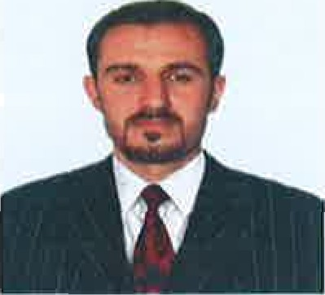SAFDAR ALI SHAH

E: mail: [**safdar59159ali@gmail.com**](mailto:safdar59159ali@gmail.com)

# Cell no: 03554116308

## **CAREER OBJECTIVE:**

With over 5 years of working experience, I bring desire to learn and work for dynamic organization to achieve my personal and professional goals. Driven by positivity and zeal to work in organization who promotes high level of Respect, Integrity, Trust and teamwork.

# WORK Experience:

# Cashier, customer service

# Taste of Lahore RESTURANT, DUBAI, UAE

# From March 07, 2019, to 31 August 2023.

##### Meet and greet Customers and make them comfortable in our environment.

##### Manage Cash Register, Billing and Invoicing, Credit cards, vouchers, or automatic debits.

1. Issue receipts, refunds, credits, or change due to customers.
2. Responsible for Cash management during the business day.
3. Manage Customer relationship
4. Get regular feedback from Customers that helps in continuous improvement to Restaurant Management team.
5. Taking staff for biometric for id, taw-jeeh center for lecture and medical test for Emirates id.
6. Resolve customer complaints, guide them and provide relevant information
7. Stay up to date on merchandise promotions, advertisements and product information.

**KENTUKY FRIED CHICKE (KFC):**

# From Jan 05, 2017, to Oct 26, 2018

Having been selected out of 300 applicants at KFC, a Multi-National Company (franchise) as Outlet Manager where below are the key responsibilities performed.

1. Supervise the Outlet across all the departments
2. Manage happy environment and customer handling.
3. Responsible for Cash Management, daily balancing and reconciling of cash & branch account/s.
4. Handle daily bank deposits & Receipts.
5. Reported to Area Manager of KFC.
6. Have been groomed by various trainings during the job.
7. Managed basic administrative tasks and managed a small team of 4 people.
8. Oversee the ambiance of the Restaurant outlet as well as & working area.

#### PARK HOTEL, BALTISTAN

From June 10, 2015, to Oct 2016

# Key job responsibilities:

* Make sure the staff appearance is proper and disciplined
* Focus on Punctuality of the staff
* Cordial & Hospitable, was part of great team which was a nice learning experience for me to customer interaction, problem understanding and problem-solving skills got developed.
* Meet and greet.

**EDUCATIONAL:**

|  |  |  |  |  |
| --- | --- | --- | --- | --- |
|  | **Degree** | **Institution** | **Year** | CGPA/Grades |
|  | D.COM  (diploma in commerce) | KPTB  Peshawar | 2015 | 1” Division |

**COMPUTER SKILLS:**

Have been exposed to working in MS Office tools and good typing skills

**LANGUAGES SKILLS:**

Language: Basic English & Urdu reading, writing and speaking skills

**PERSONAL INFORMATION:**

Date Of Birth: 02, February,1996

Marital Status: Single

Visa Status: Cancelled

Country: Pakistan

**Valid UAE Driving License**

Issue date **12,05,2022**

Issue place Dubai

Professional Reference: Could furnish upon request.